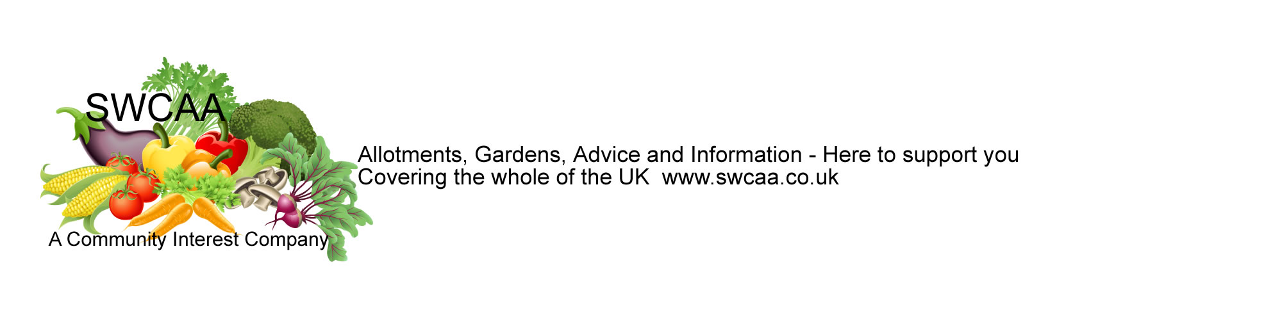
SWCAA PUBLIC, PRODUCT AND EMPLOYER LIABILITY INSURANCE– TERMS AND CONDITIONS
OUR INSURANCE POLICY is for community Interest companies and community groups and is provided through Markel International Insurance Company Limited. They are one of the longest established specialist insurers around today – They are a division of Markel International, the London based subsidiary of Markel Corporation, a leading name in specialist insurance since 1930 and are regulated by the Financial Conduct Authority and Prudential Regulation Authority, and are part of the Financial Services Compensation Scheme.
Covering your liability at law (with costs and expenses) arising from injury to any person (including death), damage to any property, or interference with the property of others arising from obstruction, trespass, or nuisance.
(THIS POLICY DOES NOT COVER LOSS OR DAMAGE TO SHEDS OR CONTENTS AND IT IS NOT A PERSONAL INJURY COVER)
Public/Products Liability
Pays your legal defence costs and damages you are legally liable to pay to other parties for injury or damage caused by your activities or products. Cover is provided for all claims occurring during the Period of Insurance.
The limit of the cover is £5,000,000 for personal liability and £5,000,000 for product liability. The insured shall be responsible for the first £100 of each and every claim in respect of third-party property damage and/or third-party Bodily Injury
Claims must be brought within UK courts and a policy excess of £100 applies to each claim which involves loss or damage to someone else’s property.
Cover includes:-
Court attendance expenses, Legal defence costs in respect of criminal proceedings brought under the Health & Safety at Work Act or Consumer Protection and Food Safety Act, Indemnity to principals for whom you are performing work, Damage to hired or rented premises (but not liability assumed under a tenancy agreement)
Cover excludes:-
Fines, penalties and liquidated damages, Loss, damage or destruction of electronic data, Injury to you or your employees, Loss or damage to property belonging to you, or in your care, custody or control, Liability arising from your professional services, Pollution, Asbestos (materials and products)
This insurance cover does not indemnify the insured in respect of any claim arising from or in connection with the burning of debris.
Tree felling, lightning, explosion, flood, subsidence or ground heave or landslip
Damage to own property or in respect of any claims arising from or in connection with loss or damage to property in the insured's care, custody, and control.
This is an individual cover and only applies to you personally.
Employers Liability
Your membership with us now includes this cover.
Pays your legal defence costs and compensation you are legally liable to pay to employees/volunteers who have suffered an injury whilst working for you. Cover is provided for all claims occurring during the Period of Insurance.
Claims must be brought within UK courts.
Cover includes:-
Court attendance expenses, Legal defence costs in respect of criminal proceedings brought under the Health & Safety at Work Act
Cover excludes:-
Use of chainsaws
Digging or excavation of large holes
Care: - In general you must take reasonable steps to avoid claims, such as First Aid arrangements and complying with local authority regulations on safety, fire prevention etc.
Making a claim: - Note: SWCAA are not insurance brokers - Claims will be dealt with directly by the insurance company
In the unfortunate event of a claim being made against you, you must inform us at once (so that we can involve the company. Normal procedure applies do not negotiate, admit liability, or make any promise or payment. Keep a log of any incidents.
Let us know if an incident occurs which might cause a claim. If you have a hall or building anyone hiring it must have their own separate insurance.
Please note that incidents are rare on allotments but do take care to avoid them!
This is an individual cover and only applies to you personally
All material in this note is provided for information only and may not be construed as legal advice or instruction. Professional advice will be sought.
All material is provided for information only and may not be construed as legal advice or instruction. Professional advice will be sought

SWCAA Discounted Seed Schemes for Members


SWCAA are pleased to be able to offer our members access to discounted seed schemes. The schemes are not run by SWCAA and you will be dealing directly with the seed companies who will send you catalogues and order forms at your request, so please do not contact the SWCAA office. Our schemes are run through Kings Seeds and Suttons Seeds.
Please remember to make sure your discount code or order number is displayed clearly when ordering.
You will need to be SWCAA members to use our schemes and must have provided us with your email address in order for you to enter the members area on our website, where you will find full details of how to order.

